VMLINK Example

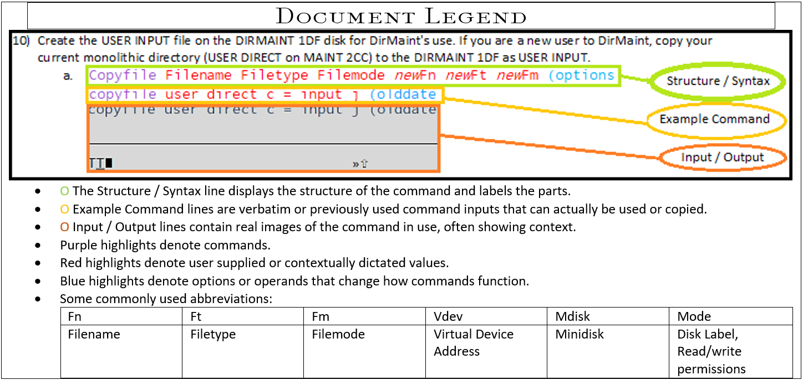

1. Establish the virtual link and if necessary use an option for write privileges.
   1. VMLINK user mdisk (option  
      vmlink pmaint cf0  
      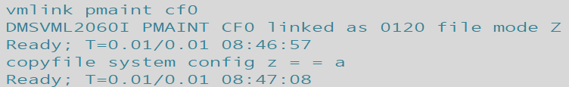
      1. For write privileges specify write as the option.  
         VMLINK user mdisk (option   
         vmlink pmaint cf0 (write
2. Copy the file renaming it or changing the filetype and specifying the filemode for the disk that the user would like the file saved to. The first set of Filename, Filetype, Filemode are for the target file and the second set of fn ft and fm set the new copies file settings.
   1. Copyfile filename filetype filemode filetype filename filemode  
      copyfile system config z = = a  
      